

Report on Investigation of Allegations of Noncompliance with the

Public Health Service Policy on Humane Care and Use of Laboratory Animals at

Primate Products Inc.

Office of Laboratory Animal Welfare Office of Extramural Research
National Institutes of Health, Office of the Director

September 8, 2015

Office of Laboratory Animal Welfare

Report on Investigation of Allegations of Noncompliance with the Public Health Service Policy on Humane Care and Use of Laboratory Animals at Primate Products, Inc.

Preface

The Office of Laboratory Animal Welfare (OLAW) herein presents its evaluation,under provisions of the Public Health Service (PHS) Policy on Humane Care and Use of Laboratory Animals (Policy), of specific animal related activities conducted at Primate Products, Inc. (PPI).

Based on the results of both an internal investigation by PPl's Institutional Animal Care and Use Committee (IACUC) and a joint site visit by OLAW and the United States Department of Agriculture (USDA), Animal and Plant Hea lth Inspection Service (APHIS), Animal Care (AC), OLAW determined that there was serious and continuing noncompliance with the PHS Policy and serious deviations from the provisions of the Guidefor the Care and Use of Laboratory Animals (Guide).

Timeline and Synopsis

On May 27, 2015, under the memorandum of understanding between USDA and the National Institutes of Health (NIH},OLAW was notified about allegations of serious and continuing noncompliance with the PHS Policy and the Guide at PPI.

On June 1, 2015, OLAW received from the People for the Ethical Treatment of Animals (PETA) an additional extensive list of allegations of noncompliance with the PHS Policy and Guide gathered by an undercover informant. The submission included written,photographic and video documentation of improper handling and treatment of nonhuman primates at the institution.

On June 5, 2015, OLAW sent a letter to Mr. Houghton, the Institutional Official (10) for PPI,to inform him about the allegations and to direct him and the IACUC to investigate and address the allegations avoiding any conflicts of interest. If noncompliance was substantiated, a reasonable and specific plan and schedule for correction was to be provided to OLAW.Allegations included a failure to report programmatic problems to OLAW,inadequate veterinary care, inadequate husbandry practices, and inadequate secondary containment. OLAW informed the institution that under Public Law 99-158 PPI was afforded a reasonable opportunity to take corrective actions before OLAW would revoke PPl's Assurance agreement halting continued funding for NIH contracts.

2

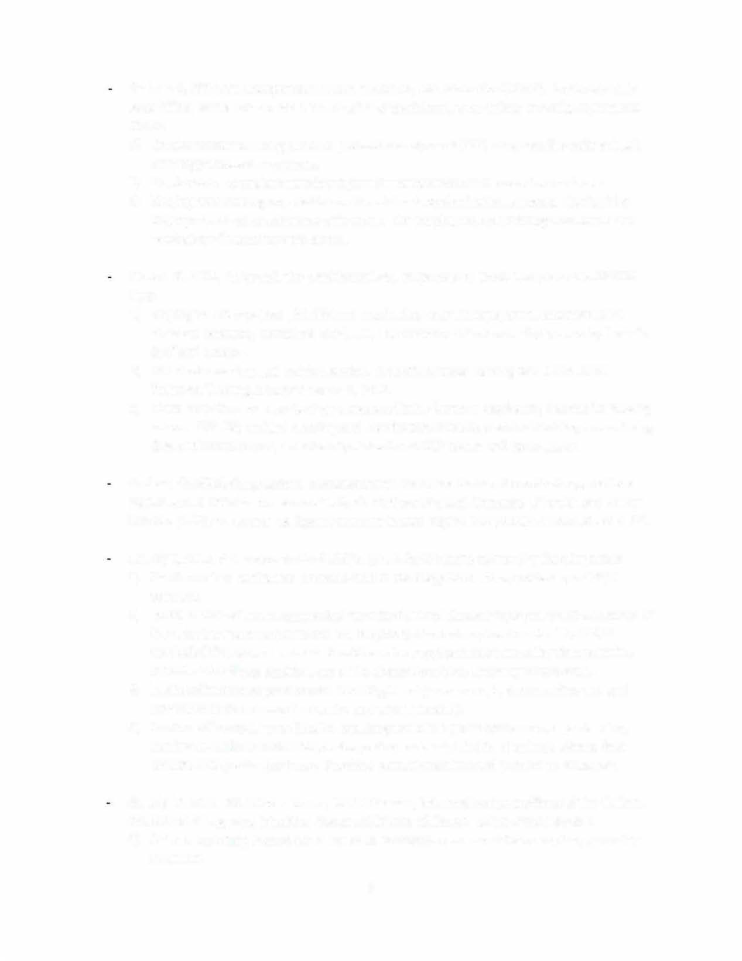

On June 5, 2015, the Occupational Health and Safety Administration (OSHA), Fort Lauderdale Area Office, sent a letter to PPI informing PPI of the following workplace hazard complaints to OSHA:
Employees are not using personal protective equipment {PPE) when working with animals carrying pathogenic organisms.
1)
- Employees are not given training to prevent transmission of diseases from animals.
- { Employees are being required to use bleach for decontamination purposes that is either improperly mixed or not mixed with water. The employees are suffering from burns and respiratory distress from the bleach.

On June 9, 2015, Dr. Rowell, the president of PPI, responded to OSHA Complaint No. 989134 that:
- Employees are provided with PPE and required to wear the equipment consistent with standard operating procedure (SOP) 111, Use of Personal Protective Equipment by Technical Staff and Visitors.
- The most recent annual training session, Zoonotic Disease Training and Blood Borne Pathogen Training, occurred March 5, 2015.
- { There have been no reports of employees suffering burns or respiratory distress from using bleach. SOP 250 entitled Cleaning and Disinfection of Outdoor Animal Holding Areas During Quarantine and Non Quarantine stipulates 1 part 10% bleach to 9 parts water.

On June 26, 2015, Congressional Representatives Theodore Deutch, Alcee Hastings, and Lois Frankel sent a letter to the Honorable Sylvia Mathews Burwell, Secretary of Health and Human Services {HHS), to request the Agency conduct its own inquiry into possible animal abuse at PPL

On July 1, 2015, PPI responded to OLAW's June 5, 2015 inquiry concerning the allegations:
- { Confirmed two nonhuman primates cited in the allegations are supported by a PHS/NIH contract.
- { IACUC review of numerous medical records of animal illness or injury substantiated some of the veterinary care concerns and the frequency of veterinary treatments. The IACUC concluded that several animals should have been euthanized at an earlier time point but indicated that these decisions are at the discretion of the Attending Veterinarian.
- { Instituted improved practices for reporting ill or injured animals, documenting care and communication between husbandry and veterinary staff.
- { Confirmed improper practices for capturing animals in group enclosures, cage cleaning, heating of outdoor enclosures, and reporting accidental deaths of animals when a bear breached the perimeter fence. Provided corrective actions and preventive measures.

On July 13, 2015, Dr. Patricia Brown, OLAW Director, informed contract officers of the National Institute of Allergy and Infectious Diseases {NIAID) and the NIH Office of the Director:
1) { Animals currently housed at PPI are to be maintained and cared for as required under the contracts.

3

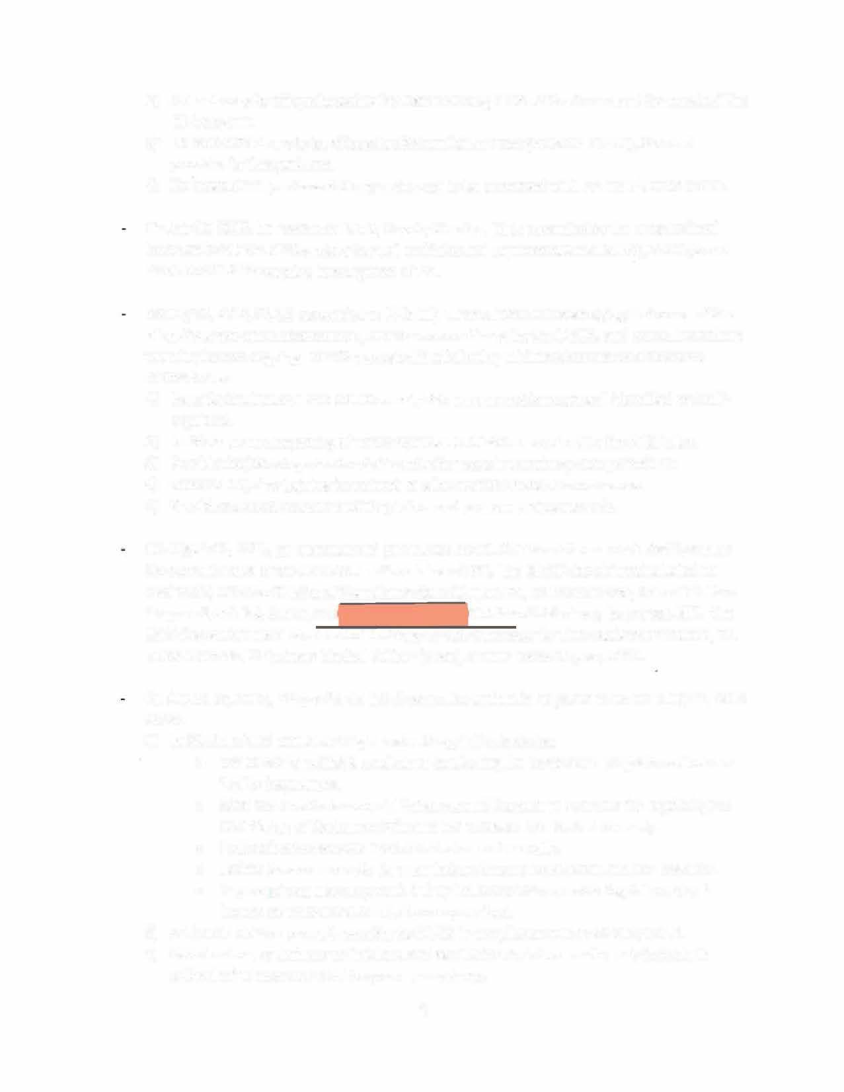
- Animals may be shipped to other facilities including NIH facilities to support the needs of the NIH program.
- No new animals are to be shipped to PPI until OLAW completes its investigation and provides further guidance.
- No new animal purchase delivery orders are to be processed with PPI until further notice.

On July 17, 2015, Dr. Lawrence Tabak, Deputy Director, NIH, responded to the congressional letter on behalf of HHS Secretary Burwell and informed Representatives Deutch, Hastings and Frankel of OLAW's ongoing investigation of PPI.

On July 28, 2015, OLAW responded to PPl's July 1, 2015 letter acknowledging that some of the allegations were not substantiated, others were confirmed by the IACUC, and corrective actions were in place or ongoing. OLAW requested the following additional corrective actions and clarifications:
- Describe institutional and IACUC oversight to ensure problems are self-identified and self- regulated.
- Institute prompt reporting of noncompliance to OLAW as required by the PHS Policy.
- Provide the job categories for staff conducting certain veterinary care procedures.
- Describe ongoing training for animals to allow transfer between enclosures.
- y Provide copies of recent IACUC inspection and program review records.

On August 11, 2015, an unannounced joint USDA and OLAW site visit was conducted to assess the current status of the corrective actions taken at PPI. The OLAW site visitors included Dr. Axel Wolff, Director Division of Compliance Oversight, OLAW, Dr. Brent Morse, Animal Welfare Program Specialist, OLAW, and! JDivision of Veterinary Resources, NIH. The USDA inspection team consisted of Dr. Gregory Gaj, Supervisor for the Southeastern States, Dr. Mario Mercado, Veterinary Medical Officer (VMO), and Dr. Aaron Rhyner, VMO.

On August 12, 2015, PPI provided a list of corrective actions in response to OLAW's July 28, 2015 letter:
- y Institutional and IACUC oversight and self-regulation includes:
o y The OLAW checklist is used when conducting the semiannual program reviews and facility inspections.
o y SOPs and the Environmental Enhancement Program to Promote the Psychological Well-Being of Nonhuman Primates are reviewed and revised annually.
o y Protocols are reviewed upon submission and annually.
o y Locked boxes are on site for submission of anonymous animal welfare concerns. o y Any employee may stop work if they feel that SOPs are not being followed or if
human or animal health may be compromised.
- PPI has an SOP on prompt reporting to OLAW in compliance with PHS Policy IV.F.3.
- y Veterinarians, veterinary technicians, and assistant technicians are the only individuals authorized to conduct veterinary care procedures.
4

- The current animal population is 98% trained to transfer using chutes. New arrivals are in the process of being trained.
- Copies of requested records are provided.

On August 13, 2015, USDA issued the inspection report from the August 11,2015 joint visit citing two findings requiring correction by PPI.

On August 18, 2015, OLAW responded to PPl's August 12,2015 letter. OLAW acknowledged the corrective actions taken and requested additional corrective actions concerning its observations during the August 11site visit:
- Provide missing information in the semiannual reports to the 10.
- Identify programmatic issues requiring prompt reporting to OLAW.
- Provide the SOP addressing animal capture and correct the euthanasia SOP.
- Provide corrective plans for findings of the August USDA inspection.
- Update the Assurance agreement with the OLAW Division of Assurances to address training and to identify the veterinarian with program authority.
- Provide safety information on heat lamps.
- Provide the current organizational structure.
- Identify other changes in the animal care and use program.

On August 20, 2015, PPI provided amendments to it Assurance agreement to the OLAW Division of Assurances addressing the requested information.

On September 2, 2015, PPI responded to OLAW's August 18, 2015 letter as follows: 1) Missing information from the semiannual reports was provided.
- PPI acknowledged that the bear intrusion was a programmatic issue that should have been reported and has erected an electric fence to prevent further intrusions.
- Relevant SOPs and PPl's response to USDA were provided.
- PPI confirmed the updated Assurance agreement.
- Safety practices and changes in the SOP for use of heat lamps were confirmed.
- An organization chart was included and changes to the membership of the IACUC were described.

Resolution

Based on its assessment of PPl's corrective actions,review ofthe supporting documents, and the information gathered duringthe site visit, OLAW found PPI fully compliant with the provisions of the PHS Policy and the Guide. The complaint filed with OSHA was successfully resolved on June 11,2015. The Hendry County investigation regarding the PPI zoning classification found no violations on the land development code. This determination was finalized on August 19, 2015. OLAW commended the 10, the president of PPI,the Attending Veterinarian,and the new IACUC Chair,as well as the animal care staff

5

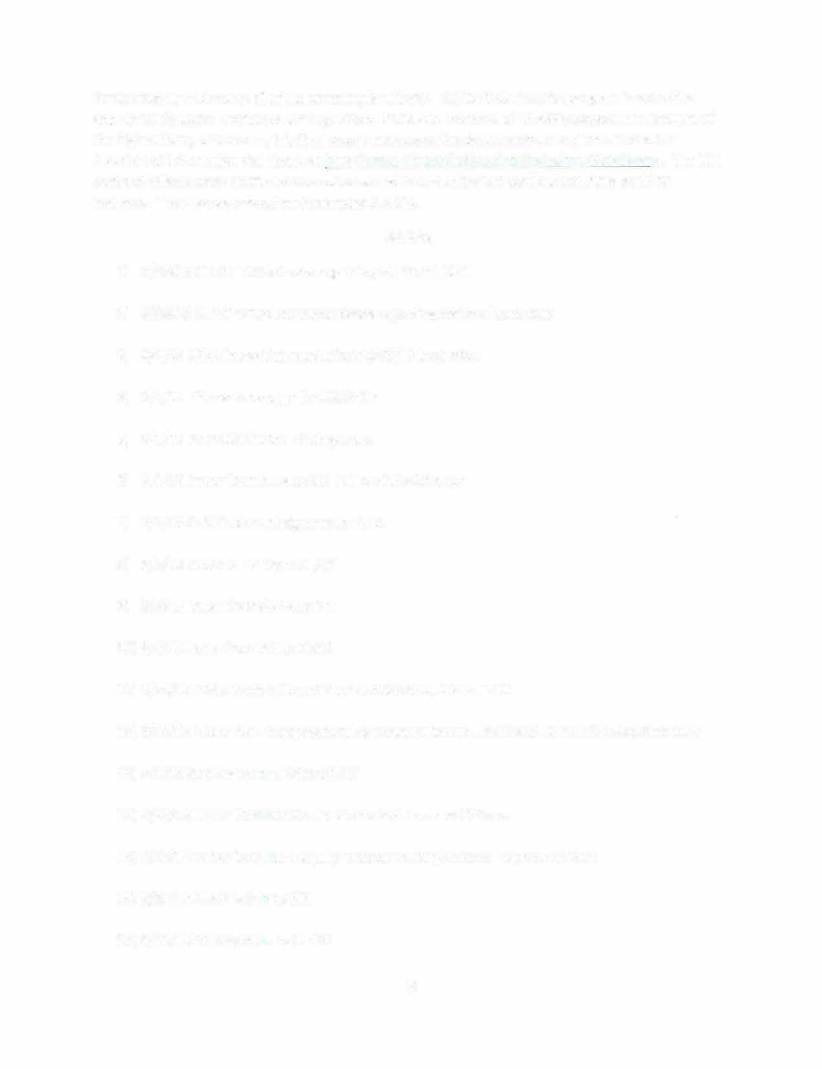

for thoroughly addressing all of the noncompliant items. OLAW finds that the program is operating appropriately under monitored self-regulation. PETA was informed of OLAW's assessment. Because of the high visibility of this case, this final report and supporting documents were placed in the NIH Freedom of Information Act Library at http://www.nih.gov/icd/od/foia/index.htm#foialibrary. The NIH contract officers were notified of the outcome and informed that all contract activities could be resumed. The case was closed on September 8, 2015.

Exhibits

  - 5/27/15 OLAW internal note regarding call from USDA

  - 5/28/15 OLAW e-mail correspondence regarding status of contracts

  - 6/1/15 USDA inspection report from 5/29/15 inspection

6/1/15 PPI memorandum for USDA file
4)

- 6/1/15 PETA submission of allegations

- 6/1/15 Letter from PETA to NIH Office of the Director 6/2/15 OLAW acknowledgment to PETA
7)
- 6/5/15 Letter to PPI from OLAW

- 6/5/15 Letter from OSHA to PPI

- 6/9/15 Letter from PPI to OSHA

- 6/24/15 Letter from Office of Research Services, NIH to PETA

- 6/26/15 Letter from Congressional Representatives to Health and Human Services Secretary

- 7/1/15 Response from PPI to OLAW

- 7/13/15 Letter from OLAW Director to NIH Contract Officers

- 7/17/15 Letter form NIH Deputy Director to Congressional Representatives

- 7/28/15 OLAW letter to PPI

- 8/12/15 PPI response to OLAW

6

- 8/12/15 OLAW letter to Dr. Hutchinson, subject matter expert for site visit

- 8/13/15 USDA inspection report from 8/11/15 inspection

- 8/18/15 OLAW letter to PPI

- 8/19/15 Hendry County Board of County Commissioner's findings

- 9/2/15 PPI response to OLAW

- 9/8/15 OLAW memos to NIH Contract Officers

- 9/8/15 OLAW letter to PETA

- 9/8/15 OLAW letter to PPI

- Email Correspondence

- Media articles

Photographs

6/1/15 Primate Products, Inc.: Investigative Photographs for OLAW Officials - PETA
{109 images)

Video

6/1/15 Primate Products, Inc.: Investigative Footage for OLAW Officials ‐ PETA

A link was provided by PETA to 48 minutes of video footage of Primate Products, Inc. OLAW reviewed the contents of the video. However, a copy of the video was not provided to OLAW for their records.

7

